**Sprint 4 Plan**

*Product:* $h0pLyf3 (Shopping List)

*Team:* Fantastic Five

*Sprint Completion Date:* Sunday, December 03, 2017

*Revision:* 1.0

*Revision Date:* Monday, November 20, 2017

*Goal:* We are working on making sure our current functionality is solid, we have a good user experience, and we can organize and sort recipes by tag.

*Task listing:*

**User Story 1:** As a shopper, I want to easily be able to organize and search/filter my recipes in a easy-to-use way.

* Create ability to add prespecified tags (3)
* Create ability to search by tags (3)
* Create ability to sort by tags (3)

**User Story 2:** As a shopper, I want the website I use to look nice and have a good user experience.

* Make sure the ingredients reflect number of recipes added (5)
* Change color of ingredients listing (2)
* Make sure refreshing page does not delete “checked” ingredients (7)
* Make sure recipe includes text field for steps (2)

**User Story 3:** As a shopper, I would like the website to look good on whatever device I’m using, whether that is a computer, a tablet, or a phone.

* Use bootstrap to make html forms responsive to mobile. (15)

**User Story 4:** As a shopper, I want the website I’m using to be bug free, so that I can use it as expected.

* Remove plus sign (+) on recipes page (2)
* Make sure recipe remove function doesn’t take amount below 0 (2)
* Clean up bootstrap references (2)
* Change greeting to first name (2)
* Make sure background is repeated as necessary (3)
* Bugs that come up during this sprint (6)

*Team Roles:*

**Connor Thurmond**: Product Owner, Developer

**Nikolai Chen:** Developer

**Anna Lin:** Developer

**Andrew Gilchrist:** Developer

**Michael Tang:** Scrum Master, Developer

*Initial task assignment:*

**Connor Thurmond**: Use bootstrap to make html forms responsive to mobile.

**Nikolai Chen**: Make sure recipe remove function doesn’t take amount below 0.

**Anna Lin**: Remove plus sign (+) on recipes page

**Andrew Gilchrist**: Make sure refreshing page does not delete “checked” ingredients

**Michael Tang**: Make sure the ingredients reflect number of recipes added

*Initial Burnup Chart & Initial scrum board:*

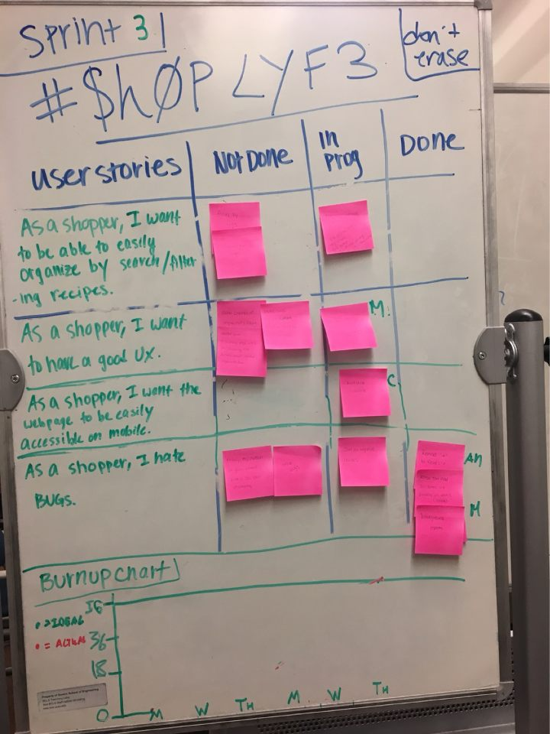

*Scrum times:* Our team will meet Monday and Wednesday from 10:45-12:00. We will meet with a TA on Thursday from 5:20 - 5:40.